Parts of an insect

Key learning points
- Insects are a type of invertebrate.
- Insects have: 3 main body parts (head, thorax, abdomen), 6 legs, and antennae.
- Many insects have wings.
- The front pair of wings in beetles have evolved to become hard shells called elytra.

Key words
Invertebrate – Animals with no backbone. Animals with no skeleton inside.
Thorax – The middle section of an insect. In humans, the thorax is their chest.
Abdomen – The back segment of an insect. In humans, the abdomen is their ‘tummy’ area.
Elytra – The hardened front pair of wings in beetles. A beetle’s shell.
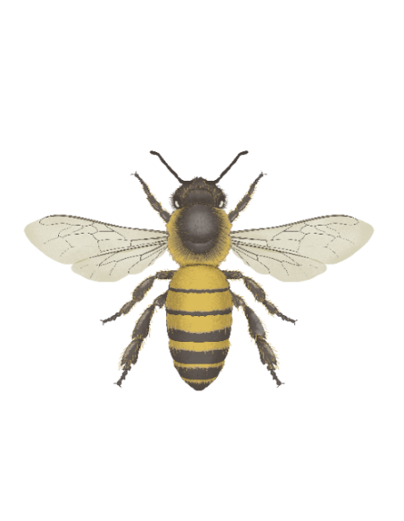
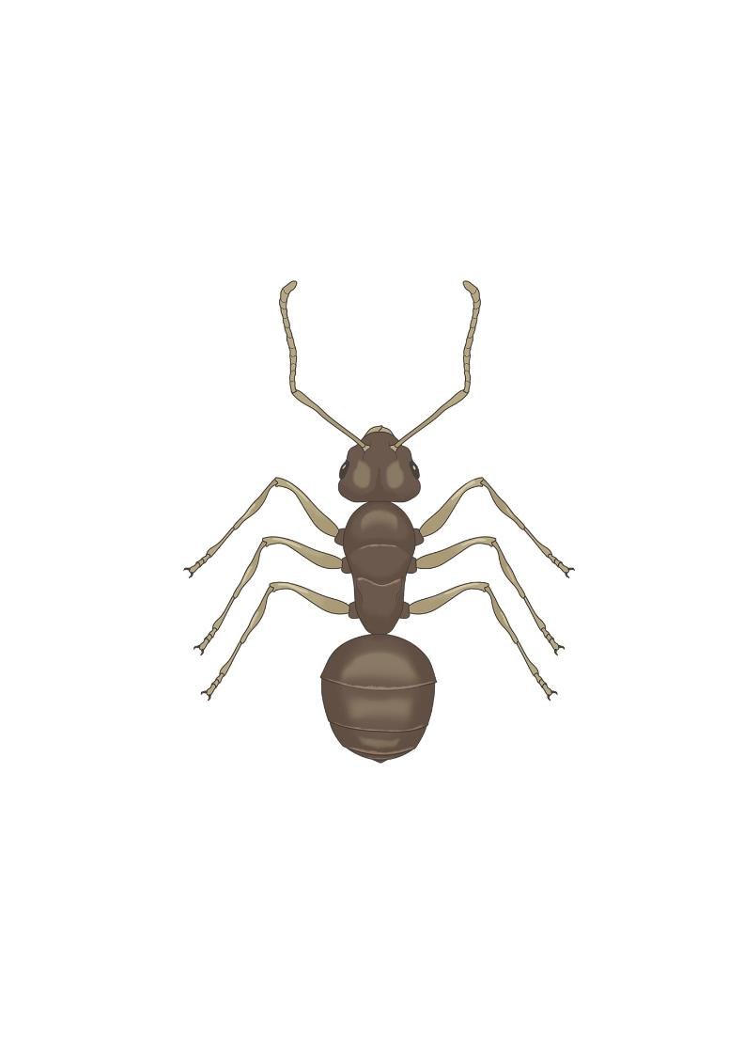
Head

Thorax

Abdomen

Antenna
(plural – antennae)

Wings

What to do
- Look at images of common insects.
- Which ones do students recognise?
- What features do the insects have in common?
- Sum up similarities. Highlight key parts of an insect: 6 legs, 3 main body parts
- Look at images of a few different animals. Use the animals’ features to identify which are insects and which are not.
- Use the worksheets to label the parts of a ladybird. (Feel free to substitute the honeybee with the other insects from the presentation if you like.)
- Students can research different types of ladybirds in the UK and colour in the picture to match their favourite one. You can also use the UK Ladybirds ID chart.

